TASK 2 - DESIGN DOCUMENTATION

For the first Phase I will be recreating the classic game, Pong.

# 1. TARGET DEVICE

My Pong recreation will be built for the Windows platform (PC’s). This is due to the large amount of accessibility people have to windows laptops and desktops. I chose to develop for PC’s because of the familiarity that people have with the tools as well. Players will be able to get used to manipulating the controls on a keyboard rather than a touchscreen smartphone.

# 2. GAMEPLAY FLOWCHART

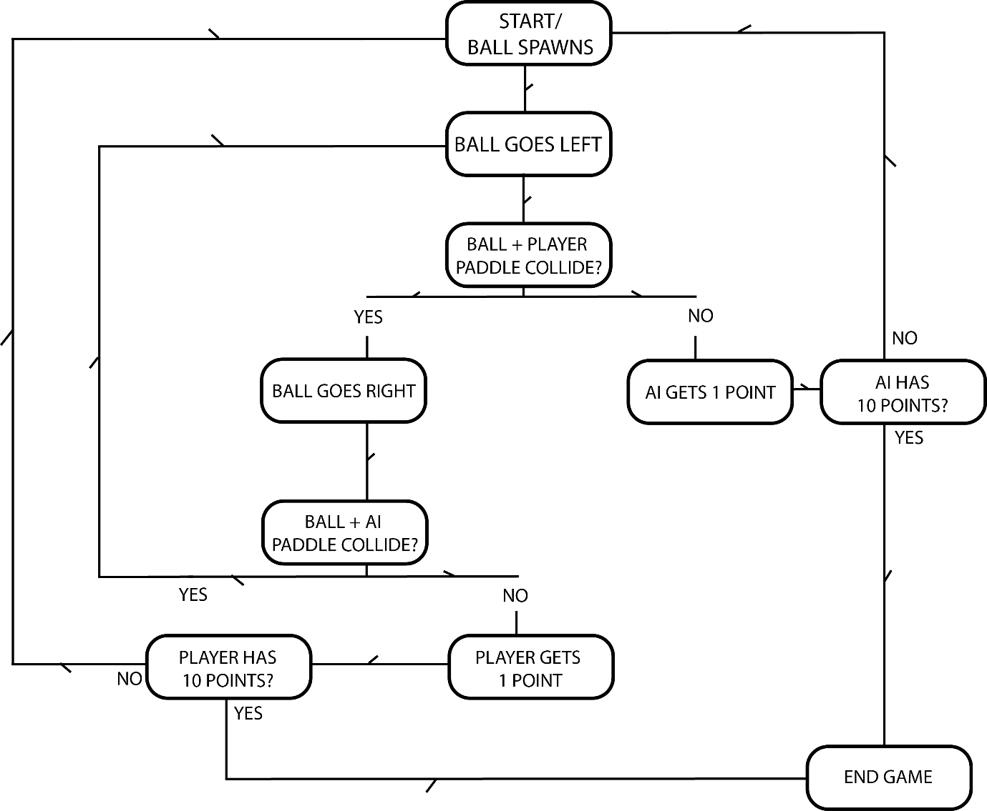

# 3. GAME MECHANICS

Pong’s mechanics are very straight forward. The ball will spawn from the opponents’ side of the field and move towards the player’s side. The player must move their paddle to prevent the ball from touching the end of their field and bounce the ball back into the enemies’ goal. A point will be awarded to the side that manages to shoot the ball into opposing goal and the ball will spawn automatically until the games objective is met. The objective is to obtain 10 points before the opponent to win.

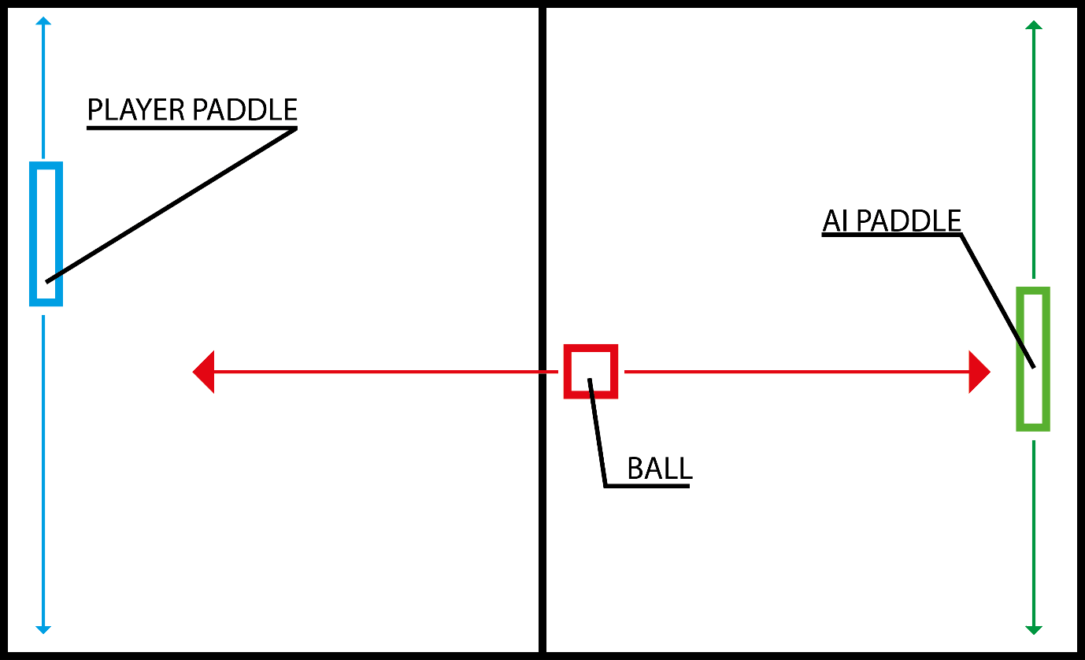

# 4. VISUAL ASSETS

This game will contain 4 assets, the background image, the two paddles and the ball. The assets were provided for free by weeklycoder.com for this specific project. The paddles and ball will be white while the background will be mostly black with white details (see image below).

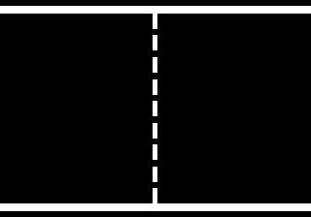

# 5. UI ELEMENTS

The game will only require two particular forms of UI. The menu screen which will have the title and the start button. Then in the main game which will have the score numbers in the top of the screen in a classic typeface.